CLCLT Website
Homebuyer Education
What is a Community Land Trust?
A conventional community land trust (CLT) is a nonprofit, community-based organization that works to provide perpetually affordable homeownership opportunities. In the truest sense, a CLT acquires land and removes it from the speculative, for-profit real estate market. CLT’s hold the land they own “in trust” forever for the benefit of the community by ensuring that it will always remain affordable for homebuyers.

CLT’s follow local laws and zoning requirements as well as the organizational bylaws put in place when the CLT was established. CLT’s are governed by a board of directors that is made up of community members and CLT homeowners. Members of the CLT elect the board of directors.

There are over 240 CLT’s in the nation today as well as several organizations using the CLT model to provide affordable homeownership opportunities in Minnesota. There are CLT’s in cities, suburbs, and rural areas.

CLT Homeownership
Through CLT programs, homebuyers who meet the CLT’s income guidelines will receive affordability assistance from the CLT to purchase a home below the market-rate sale price. At closing, the homebuyer will enter into a long-term agreement with the CLT which will preserve the affordability of the home. When a home is resold, the CLT homeowner passes the home and the long-term affordability agreement on to another limited-income household. The sales price is determined using the CLT resale formula allowing the home to stay affordable for future generations.

CLT Perpetual Affordability Cycle – SAMPLE GRAPHIC ONLY!!!
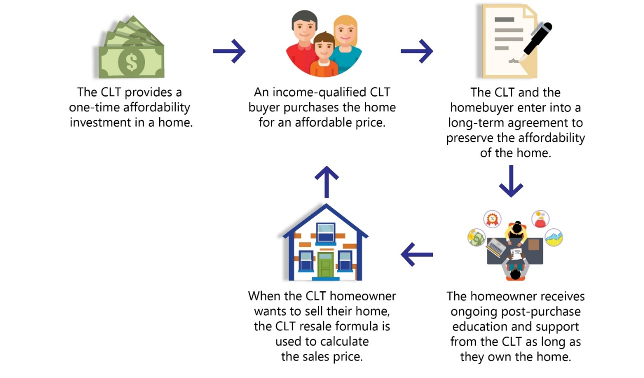

Benefits of CLT Homeownership Include:

Affordability
CLT homes are more affordable than homes purchased on the open real estate market because of the CLT affordability assistance provided to homebuyers.

Mortgage
Consistent and affordable mortgage principal and interest payments.

Community
CLT homeowners are members of the organization. As part of this larger community, they can choose to participate in the CLT community through voting, volunteering, and/or becoming a CLT board member or serving on a committee.

Stability
Homeownership provides stable housing costs and security from eviction. This stability provides a solid foundation, giving homeowners the opportunity to pursue other goals such as going back to school or working higher-paying jobs.

Support
CLCLT homebuyers have the support of CLCLT and its staff while they own their homes. CLCLT provides a wide array of support to its homeowners including homeowner events, hands-on home improvement workshops, and answers to common questions regarding homeownership and home maintenance.

Qualifications

How do I Qualify for CLCLT Homeownership?
All CLCLT homebuyers must earn less than 80% of the Area Median Income (AMI) for the Twin Cities Metro area and are based on household size. The household income is determined using the gross annual income for all individuals 18+ years of age who will be living in the home at the time of closing. Income limits are determined by the Department of Housing and Urban Development (HUD) and can change annually. Income limits are listed below:
Household Size Income Limit
1 $54,950
2 $62,800
3 $70,650
4 $78,500
5 $84,800
6 $91,100
7 $97,350
8 $103,650
CLCLT Homeownership Options

Homes for Sale
CLCLT partners with builders and developers to create new homes and sell them to CLCLT homebuyer at below market-rate prices. This also includes the resale of existing CLCLT homes and properties developed solely by the CLCLT. Homes can be single-family homes, duplexes, multi-generations homes, townhomes, and condominiums, and remain affordable for future limited income buyers. Homes for Sale are purchased directly from the CLCLT.

Program features:
- Homes can be new construction, fully rehabbed and/or existing homes available for resale
- Sold to income-qualified buyers at below-market prices
- Single-family homes, duplexes, townhomes, multi-generation homes and condos are eligible for purchase
- No minimum income required

Homebuyer Initiated Program (HIP)
HIP helps families and individual purchase homes that are for sale anywhere in the city of Minneapolis by providing both an affordability grant to apply towards the purchase of the home, and a post-purchase rehab grant to address deferred maintenance items identified at time of purchase. Examples of eligible rehab include lead & asbestos testing and abatement/mitigation, plumbing code issues, electrical code issues, window and door repair/replacement, grading, heating, and roofing. HIP allows buyers to choose homes in the Minneapolis neighborhoods and communities that meet their needs.

Program features:
- HIP Affordability Grant allows qualified homebuyers to reduce the amount of mortgage financing needed to purchase a home for sale on the open market in Minneapolis.
- HIP Rehab Grant helps to ensure that an expensive repair will not jeopardize the financial stability of the new homeowner within the first few years of homeownership.
- Single-family homes and duplexes are eligible for purchase
- No minimum income required
- Facilitates buyers being able to choose homes in the Minneapolis neighborhoods and/or communities that meet their needs
- Homes purchased through HIP include new construction, foreclosures, and vacant homes.

Project: Sustained Legacy
Project: Sustained Legacy is designed to assist existing homeowners who are facing mortgage foreclosure and/or tax forfeiture to remain in their homes by providing an affordability grant to pay off past-due balances (up to a certain amount). Project: Sustained Legacy goes one step further and provides post-closing assistance to address what is oftentimes significant deferred maintenance on the home. Through Project: Sustained Legacy, the CLCLT has been able to assist almost one dozen long-term Minneapolis homeowners to remain in their homes and return the homes to a safe, livable condition.

Program features:
- Provides an affordability grant to apply towards past-due balances on mortgages and/or property taxes (up to a certain amount)
- Provides post-closing rehab to address deferred maintenance on the home
- Single-family homes and duplex homeowners are eligible for this program
- No minimum income required

CLCLT Application Process
- Attend an informational virtual orientation session
- Complete CLCLT application form and include the following:
  - Accurate size of household
  - Two months most recent paystubs for all jobs (generally 4-5 paystubs depending on pay cycle)
  - Two years most recent federal tax returns (three years federal tax returns w/Schedule C: Profit/Loss Worksheet if self-employed)
  - $20 household application fee
  - Other income documentation as-required (example: Social Security benefit letter, Public Assistance benefit letter, spousal or child support payment verification, pension/retirement payment, etc.)
- Attend a first-time homebuyer Home Stretch workshop *Framework certificates are not accepted
- Obtain lender pre-qualification from a CLT-partner lender

FAQ’s

Who Lives in CLCLT Homes?
CLCLT homeowners include families, children, grandparents, couples, and unmarried persons. They are social workers, bus drivers, teachers, students, office workers, business owners, stay-at-home parents, artists, and musicians.

Some our lowest income homebuyers would not have been able to buy a home except through the CLCLT programs. Other CLCLT homeowners could have afforded to buy a home on the open market, but most likely would have qualified for a home in need of significant repairs which would have been too expensive for them to complete. The CLCLT program helps these families and individuals purchase a higher quality home than they would have otherwise been able to afford.

How Do I Qualify for CLCLT Homeownership?
All CLCLT homebuyers must meet our income eligibility guidelines (go to our [Qualifications] page for current income limits) and obtain a pre-qualification letter from a CLCLT partner lender.

What Happens if I get a Raise or a Higher Paying Job After Closing?
CLCLT homebuyers must meet our income guidelines up to closing. After you close on a CLCLT home you no longer need to meet our income guidelines.

How do You Determine the Household Size?
All persons who will live in the home at the time of closing are included when determining the household size. For example, a married couple and their child would be considered a three-person household. Another example of a three-person household would be two adult children living with their aging parent.

Does my Household Size Affect My Eligibility for Purchasing With the CLCLT?
The composition of your household does not impact your eligibility for CLCLT programs.

I am Already Pre-Approved with Another Partner Lender. Can I Work with Them to Purchase A CLCLT Home?
CLCLT homebuyers must work with a CLT-partner lender. If you are currently working with one of our partner lenders you do not need to reapply.

What Types of Loans Work with the CLCLT?
CLCLT homebuyers must qualify for a Conventional mortgage (30-year mortgage with a fixed interest rate). The CLCLT does not work with FHA, ARM, VA or Interest-Only mortgages.

Do I Have to Work with a CLCLT Realtor?
You may choose to work with any realtor of your choice. If you don’t have a realtor, we can provide a list of realtors who have worked with our buyers in the past.

Who Will Pay the Property Taxes?
CLCLT homeowners pay all taxes and assessments associated with their property. As with all homeowners, the interest portion of your mortgage payment is tax deductible. If you itemize your federal income taxes, the property taxes that are paid are also tax deductible.

How do Homes Become Part of the CLT?
CLCLT homebuyers receive an affordability grant from the CLCLT to apply towards the purchase of their home. At closing, the homebuyer will receive title to the house, garage, shed and any improvements they make to the property (i.e. Buildings & Improvements). The CLCLT will obtain title to the land thereby bringing the home into the trust and ensuring the long-term affordability of the home for future income-qualified homebuyers.

